Application / Nomination to become a member of the Board of Trustees
2018 - 2019
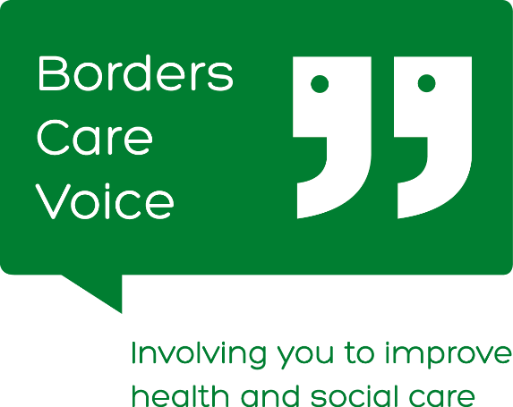

You must be a member of Borders Care Voice to stand for the Board of Trustees. Nominations for Trustees representing CORPORATE members (Companies, SCIOs and CICs) must have permission from one of their own Trustees or Directors. Borders Care Voice is Scottish Charitable Incorporated Organisation (SC043731). A copy of the Constitution is currently available by emailing: admin@borderscarevoice.org.uk.

Section 1: Name of person who wishes to join Board:
- If you are a current member of the Borders Care Voice Board of Trustees and are requesting re-election, please specify information:
- Number of years of service: |  |  | Offices Held:
To stand for election or re-election at AGM you must be nominated by one other member of Borders Care Voice. Please complete their details here.
Borders Care Voice Member Nominating you to join the Board: |  |  | Signature: |  | Date:
Your Correspondence Address & Postcode:
Telephone number:

Email address:

Accessibility or Information requirements:

- Section 2: (not required if seeking re-election)
- Please briefly explain why you think the work of Borders Care Voice is important to you.
Please briefly explain why you wish to join the Board of Trustees
Skills & Experience
Please see some examples below - Please tick boxes as appropriate.

 | Fundraising |  | Legal/HR
 | Project Management |  | IT/Systems
 | Business Planning |  | Change Management

Please detail these below and add any other skills and experience you could bring to the work of the Board.
Reference
All nominees must provide the name and contact details of a Referee

Name:

Address:

Telephone Number & Email:

Section 3: Potential for Conflicts of Interest (all nominations to complete)
If members of the board are closely involved with health and social care providers, including statutory services in the Borders we need to be aware of them. Board members must, where possible, place the interests of Borders Care Voice before their own organisations and must act in accordance with the Board’s Conflict of Interest Policy. Please list any roles you are involved in which might give rise to a conflict of interest and how you might manage these. If there are none please state this.
Declaration:
Borders Care Voice is a Scottish Charitable Incorporated Organisation. Legally some people cannot join the Board of Trustees and could face criminal charges if they did so. In general terms this includes:
- someone with an unspent conviction for dishonesty or an offence under the Charities and Trustee Investment (Scotland) Act 2005;
- an undischarged bankrupt;
- someone who has been removed under either Scottish or English Law or the courts from being charity trustee; and / or
- a person disqualified from being a charity trustee
If you are not sure whether any of these apply to you please contact us. By signing below you confirm that you are not disbarred from being a Charity Trustee.

By signing this declaration you also agree to undergo a PVG Membership Application/Record Check for regulated work with adults and to complete a self-declaration form.
Signature of applicant to join Board: |  | Date:
Any key information that is not confidential will be available to all members of Borders Care Voice prior to AGM so they can make an informed decision when electing members to the Board of Trustees. If elected, your information will be held by Borders Care Voice staff in a secure location and will not be passed onto any third parties. You can get more information in our Data Privacy Policy here or by contacting us on 01896 757290 or emailing admin@borderscarevoice.org.uk

Please return this form by 5pm on Thursday 6th September
To admin@borderscarevoice.org.uk or post to Borders Care Voice, 3rd Floor, Triest House, Bridge Street, Galashiels, TD1 1SW

For Office Use Only
Date received: | Accepted at AGM (Date) | Self Dec. Complete  (Date) | PVG Form Given  (Date) | PVG Complete  (Date) | Initial When complete

